**Experiment NO 9**

**Effect of pre heater on bench top cooling tower trainer**

**Introduction:**

A cooling tower is a heat rejection device, which extracts waste heat to the atmosphere through the cooling of a water stream to a lower temperature. The cooling tower is used to describe both direct (open circuit) and indirect (closed circuit) heat rejection equipment.

**Parts of cooling tower:**

* Water Pump
* Water filter
* Water Distributor
* Water Flow meter
* **Centrifugal fan with 0.5 and 1 kw pre heater**
* Air distribution chamber
* Water basin
* Tower column
* Manual Valve
* Float Valve
* Float Switch

**Diagram:**

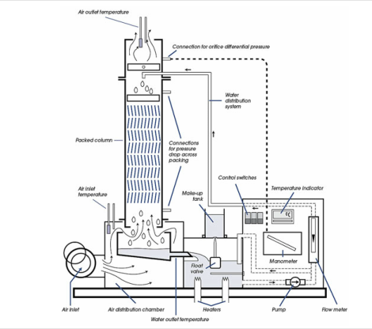

Fig no 9.1:Diagram of cooling tower

**Explanation:**

**Water Circuit:**

Warm water is pumped from the load tank through the control valve and water flow meter to the column cap where its temperature is measured. The water is uniformly distributed over the top packing deck and, as it spreads over the plates, a large thin film of water is exposed to the air stream. During its downward passage through the packing, the water is cooled, largely by the evaporation of a small portion of the total flow

**Air Circuit:**

Air from the atmosphere, pre-heated by external means if desired, enters the fan at a rate, which is controlled by the intake damper setting. The fan discharges into the distribution chamber and the air passes wet and dry bulb thermocouples and the water is cooled. On leaving the top of the column the air passes through the droplet arrester, which traps most of the entrained droplets and returns them to the packings. The air is then discharged to the atmosphere via the air measuring orifice and further wet and dry bulb thermocouples. All of the foregoing may be observed through the transparent structure of the column.

All the temperature are inducated by digital temperature indicator and thermocouple selector switch.

**Formulas:**

Range=T5-T6

Approach=T6-T2

Effectiveness=Range/(Range+Approach) *100

**Table with explanation:**

**(PRE HEATER=0.5 KW)**

**TABLE 1:**

|  |  |  |
| --- | --- | --- |
| **Measurement points** | **Measurement** | **Units** |
| Air Velocity | 6.3 | m/s |
| Water flow rate | 4 | lpm |
| Air inlet temp(dry bulb)T1 | 19 | **°**C |
| Air inlet temp(wet bulb)T2 | 19 | °C |
| Air outlet temp(dry bulb)T3 | 20 | °C |
| Air outlet temp(wet bulb)T4 | 22 | °C |
| Cooling Tower water inletT5 | 23 | °C |
| Cooling Tower water outlet T6 | 19 | °C |
| Make up water temp T7 | 13 | °C |

**From Table**

Range=23-19

=4°C

Approach=19-19=0°C

Effectiveness=(4/4)*100

=100%

**Applications:**

Common applications are:

* Cooling the circulating water used in [oil refineries](https://en.m.wikipedia.org/wiki/Oil_refineries),
* [Petrochemical](https://en.m.wikipedia.org/wiki/Petrochemical) and other [chemical plants](https://en.m.wikipedia.org/wiki/Chemical_plant),
* [Thermal power stations](https://en.m.wikipedia.org/wiki/Thermal_power_station), [nuclear power stations](https://en.m.wikipedia.org/wiki/Nuclear_power_station)
* And also [HVAC](https://en.m.wikipedia.org/wiki/HVAC) systems for cooling buildings.